Sewellia lineolata
The Reticulated Hillstream Loach

Easy to spawn or a whole lot of luck?

By Eric Bodrock

I first saw these fish in the early part of 2004 and I knew right away that these were one of those fish that I had to have. The basic brown colored “Chinese Butterfly,” probably Beaufortia or Gastromyson sp. sold in pet shops, have been in the hobby from time to time for years now and are not a fish that folks make a fuss over. However, the S. lineolata, with its attractive color and markings, grabs your attention and won’t let you go! I was fortunate enough to get my hands on a group of twelve wild adults in 2005. Unfortunately, at the time, I was not ready for them and they went into a fifteen-gallon tank, put on my list of fish to “work on spawning.”

In June of 2007 I set up four adults in a twenty-gallon long aquarium along with a couple of Homaloptera tweediei. The back of the aquarium had a three quarter inch hole thru the glass on the right side about four inches from the bottom. I rigged up a half-inch PVC bulkhead fitting thru the glass and extended hard pipe about four inches in towards the center of the aquarium. I placed a 90° elbow on the end of the pipe to allow aim towards the left side. A submersible power head with a foam pre-filter was placed inside the aquarium near the left side and vinyl tubing was used to connect the power head discharge to the PVC fitting on the outside of the aquarium. This would allow water to flow from right to left to produce my fake ‘hill stream current’ hopefully mimicking the water movement found in the S. lineolata’s natural environment. I covered the open end of the elbow with plastic screen so that none of the fish could swim into the pipe. I didn’t want them to like the current too much and get stuck inside the tubing or killed inside the power head. The tank was only filled two thirds of the way--just enough to keep a Hydro-sponge® filter working with a moderately heavy airflow.

I covered the entire bottom of the aquarium with a thin layer of fine brown sand that I collected from a local stream. In a twelve-inch area in the center of the aquarium, in the path of the water current, I added a one-inch thick layer of pea sized-gravel. A one to one-and-a-half inch layer of round river rock was placed on top of the pea gravel. My thinking here was that in the event of a spawn, their eggs (or fry) could easily hide in the gravel pile, protected from being eaten by the adults. A baseball-sized clump of Java Fern was added to the aquarium. The current blew it into the area of the power head and that is where I left it. A few flat oyster shells that I found at the beach were placed against the stones at the edge of the gravel pile to provide hiding places for the adults and act as a pH buffer for the water.
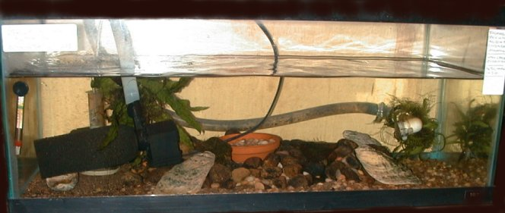
My 20-Gallon Long artificial “Hillstream” spawning aquarium.

The same day I was setting up the lineolata’s aquarium, I was also setting up my three pair of Rainbow Shiners (Notropis chrosomus) in another aquarium to attempt spawning them. I started wondering and thought that the Shiners would love the ‘hill stream current’, too. Therefore, I decided to add a pair of the Rainbow Shiners in with the Loaches and see what happened.

To simulate a Stone Roller’s (Campostoma sp.) nest I moved some of the larger stones from the center of the rock pile and made a pit just large enough to add a one-inch deep, four-inch round, terra cotta flowerpot coaster. The coaster sat about one half-inch higher than the rest of the stones. I filled the coaster with pea-sized gravel similar to that in which the Shiners’ were said to deposit their eggs in the wild.

On June 27, 2007, the water temperature was at 74°F, pH 7.0 -7.2, GH 200 – 225ppm and KH around 70ppm. No salt or other chemicals were used in the aquarium except for a de-chlorinator when the water was first added. The aquarium received indirect, fluorescent light for about twelve hours a day. All the fish appeared to be happy in their new set up. The pair of Rainbow Shiners were constantly swimming and playing in the current and all the Loaches were hidden. They were fed twice a day with a diet consisting of live black worms, frozen bloodworms, live baby brine shrimp, live daphnia and a little bit of finely crushed flake foods.

On the morning of June 30, I found that my two pair of Rainbow Shiners had spawned, depositing a hundred or so eggs in the artificial Stone Rollers nest in their fifteen-gallon spawning aquarium. Thinking that the pair of Shiners in the twenty-gallon ‘hill stream’ aquarium may have also spawned, I pulled the coaster out and dumped it into a plastic shoebox. I removed the gravel, grabbed a bright flashlight and looked for eggs. As I intently looked into the shoebox, I didn’t see a thing except for a little bit of dirt and sand. When I tilted the container a bit, I thought I saw some movement. After looking several more minutes, I thought maybe it was only water droplets running on the underside of the shoebox as I tilted it. To double check, I slid the shoebox halfway off the counter top to dry off the underside, but much to my surprise, it wasn’t wet at all! After fifteen minutes of the flashlight inspection and my eyes playing games with me, I convinced myself that I did see something moving about on the bottom. It just about drove me crazy (and blind!). I called my fish geek girlfriend Regina over from her half of the fishroom and told her to get her glasses on and see if she could see anything.

She spotted something moving right away. Using a turkey baster I sucked up what I guessed was a fry, along with some sand and debris, and squirted it into a white cereal bowl. With the tip of the baster, I stirred up a whirlpool in the bowl causing all the sand and dirt to settle in the middle. Within a minute or so, five of the tiniest, little slivers that you could possibly see darted from the debris. With light colored bodies as thin as a hair and just over a millimeter or maybe two in size, it was baby fish! They skipped across the bottom in short bursts. Regina was more excited than I was and yelled out “Baby Loaches!” I thought so too at first, and then remembered what I was really looking for in the first place. Not knowing what newly hatched Rainbow Shiners look like, I couldn’t bet the farm that I had Loach fry instead of Shiner fry. I dumped the fry back into the shoebox, filled it with water from the spawning tank, added a small bunch of Java Fern and an airstone, and crossed my fingers that I could grow them up.

Two days after the first find of these tiny fry, I found a single Rainbow Shiner fry from the known Shiner spawn. He was active at the surface and much, much larger….I knew at that moment that I truly did have Loach fry! I checked the coaster two or three times a day for eight days and always found fry, anywhere from two to six each time. I added all new fry to the others in the shoebox.

Several days after I knew they spawned, I removed the Rainbow Shiners and the H. tweediei from the spawning set up to eliminate any chances of these fish eating the young. In addition, I unplugged the power head, fearing that the tiny fry might make their way through the foam pre-filter and be destroyed in the power head’s impeller.

Once the fry were first set up in the grow-out shoebox; I started wondering what to feed these outrageously tiny fry. I did add the clump of Java Fern thinking there might be some tiny “bugs” or algae in it that the fry could feed on. For that same reason, I siphoned some of the sand from the spawning tank into the shoebox as well as APR, fine powdered rotifers and copepods that, mixed with water, enabled it to sink. I dumped in some green water and sponge scrunge for good measure, as well as smaller, algae covered rocks from other tanks in my fishroom. I didn’t even consider newly hatched brine or microworms because they would be way too large to be eaten. I’m telling you again, these fry are tiny!

The growth rate of the fry was very slow for the first few weeks. At twenty-six days, on July 26, some reached four millimeters in total length and their bodies started filling out a little. This is considerably larger than the newborns, but still really small for their age compared to the growth rate of hundreds of other fish I have spawned over the years.

Under the macro setting on my camera, I was able to see a couple of black spots on their light colored bodies that couldn’t be seen with the naked eye. Once they reached this size, microworms were added to their diet, along with all the above mentioned.

By day thirty-four, Aug. 3, some young had grown to just over half a centimeter and their growth rate finally started to speed up. In addition, newly hatched baby brine was added to their menu. I have had problems in the past with Hydra showing up when baby brine is overfed. If that happened, it would surely wipe out the small loach fry so I only used a very small amount.

At forty-one days, August 10, the largest fry seen in the grow-out shoebox was one centimeter in total length, which is from head to tip of tail. Some of the fry were still as small as half a centimeter! The fry were added to the grow-out container for a period of only eight days after I found the first baby. In addition, the ‘hill stream’ tank was only set up for three days before the first fry were seen, so no fry in the grow-out container could be more than eleven days apart in age. This proves to me that the growth rate of the young varies considerably with each individual. Much to my surprise, the largest one in the grow-out box was larger than fry seen in the spawning aquarium!

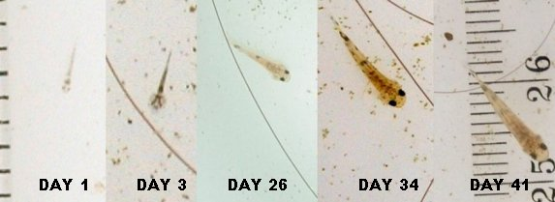
Fry ranging in size of just 2 millimeters on day 1 to a centimeter on day 41.
I used a hair to give a reference on just how small these fry really are!

On August 20, at day fifty-one, I added the only seven young I had in the grow-out box back into the aquarium with the adults. I had already been watching at least one youngster swimming around with the adults for a week and a half without them seeming to bother him. I figured that all the young would do better in the larger tank rather than the small, possibly unstable, shoebox. At this time, I also turned the power head back on to get the ‘hill stream’ system running again.

Later that day, I noticed a good bit of activity between the adults. Could having the water current flowing again trigger them to spawn? I pulled up a chair and sat quietly, watching to see if I could catch any spawning activity. What I did see was a male chasing a female all around the tank. Whenever she would stop, usually on the glass, the male would skip and bounce all around her while pushing his head into her body. It appeared he was trying to get under her. If he did manage to push his way under her body, she would swim off and he would follow. This went on non-stop for about an hour until they seemed to lose interest, or maybe got tired, and each went their own way. I assume that was part of the courtship, but I never did see them actually spawn.

Curiosity and wishful thinking got the best of me. I needed to see if they had spawned again. The next afternoon I pulled the coaster out to see if I could find some eggs. Now equipped with a jewelers lighted magnifying glass I was surprised at what I found; a single fry just over two millimeters in length and a tiny clear egg that appeared to have already eyed up! I removed the single fry and left the egg in the bowl of water. The next day, I found a baby, just two millimeters in total length, as thin as a hair and almost clear. This newborn baby was noticeably thinner than the fry I removed the day before which led me to believe that they were from different spawns, maybe a few days apart. Since I had now found tiny fry on many occasions, I leaned towards the idea that these fish were spawning regularly. I would speculate the reason not many fry are found growing out in the spawning aquarium is that the adults, larger siblings or any other fish that may be present were eating them.

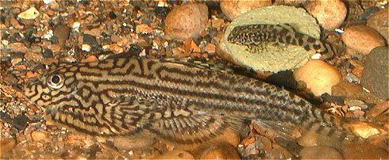
One of the breeder males along side a 67-day-old juvenile who is eagerly munching on a Spirulina wafer. I think it is important to offer a wide variety of foods.

On September 3, I was fortunate enough to be walking by the ‘hill stream’ set up and noticed a male in pursuit of a female again. I grabbed a chair and planted myself in front of them. Within a couple of minutes, I saw a pair that appeared to be locked together swim into open water and sort of shake for a few seconds. It happened so quickly that I didn’t realize what had happened until it was over. A few minutes later, they repeated the activity, this time in the middle of the aquarium towards the back glass where I was able to watch the entire sequence. The male swam under the female up to her right side and clamped his pectoral fin between her pectoral and pelvic fins. They slightly curled together, shook for four or five seconds and a stream of about twenty tiny white eggs fell from them to the bottom. Several minutes later, they repeated the process but I could not see any eggs released. I watched for another half hour but didn’t see any further spawning activity at all.

Thinking that the female had depleted her eggs and they were finished spawning, I decided to try to collect some eggs from the aquarium. I had seen the area where some of the eggs had fallen. I removed the top layer of river rocks, pushed a gravel washer into the gravel bed and siphoned enough water to fill up a shoebox. Along with some debris, sand and small blackworms, I hoped there were some eggs in there too! Since I had the top layer of river rocks removed to try and collect eggs, I decided to make the layer of pea-sized gravel deeper. My thought here was to make a deeper layer to protect eggs (and fry) better in future spawns.

From this point on, I have decided to leave the set up alone for a while and simply see what happens. It would be nice to see fry just appear without putting a lot of time into them. These fish have provided me with countless hours of enjoyment and amazement, but I do have a rather large waiting list of fish I plan to “work on spawning!”

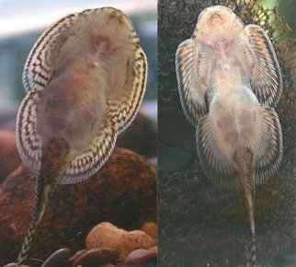
A pair of Sewellia lineolata: Female on the left, Male on the right

Additional Random Notes, Observations & Conclusion

- Adult males and females are easy to distinguish by their head formation when viewed from above or the underside. Males have a more pronounced head. The head of the females appears almost to run into their pectoral fins, making the entire front of the fish look round. My males are two inches in total length and the females are a bit smaller at one and three quarter inches. I have two pairs in the spawning set up.
- In the breeding set up, I occasionally add some algae covered, golf ball sized river rock that I find in my local stream. The Loaches seem to love it, pushing their way though the algae and even laying in it. Normally, within a few days, the rocks are stripped clean. Even though they eagerly accept live black worms and frozen meaty foods, algae may play an important role in their diet and conditioning for breeding.

- Did you notice I mentioned several times in the article that the fry are tiny? That’s because they are the smallest fry I’ve ever seen in my thirty-four years of fishkeeping! It kept me up at night for several days thinking about how in the world I would grow out such tiny fry.

- When provided with the right conditions, I found these fish are easy to spawn and they spawn all the time! The trick is to find a way to get their eggs and/or fry away from all the other fish who will consume them. This may be the reason why there are several reported spawnings of them in the hobby where individuals simply find young fish in their canister filters, power filters or sumps. Simply removing the adults after spawning occurs would work great. However, if you do this, you will have to have a lot of patience. I think you will have to wait a good while to see results/fry in the spawning set up because the fry are so tiny. Knowing for sure that I have at least eight young in the tank, in a range of sizes up to a centimeter, trying to see all at one time is impossible. I am lucky to see one or two at a time!

If you have an opportunity to get your hands on some of these guys, do it, you won’t regret it. They have proven to be one of the most interesting fish that I have ever worked with and successfully spawned.

Eric Bodrock
September 2007

